

SOFTWARE CONSTRUCTION & DEVELOPMENT
PROJECT DOCUMENTATION
GROUP MEMBER :
SHAHZAIB ADIL 55652
SALMAN SAGHIR ABBASI 55071
PRESENTED TO :
SIR ISLAM ABBASI

Artifact No 1
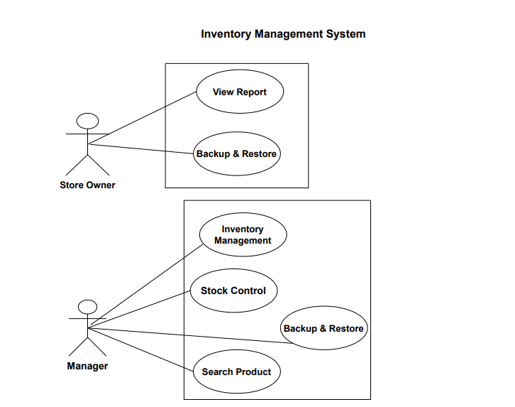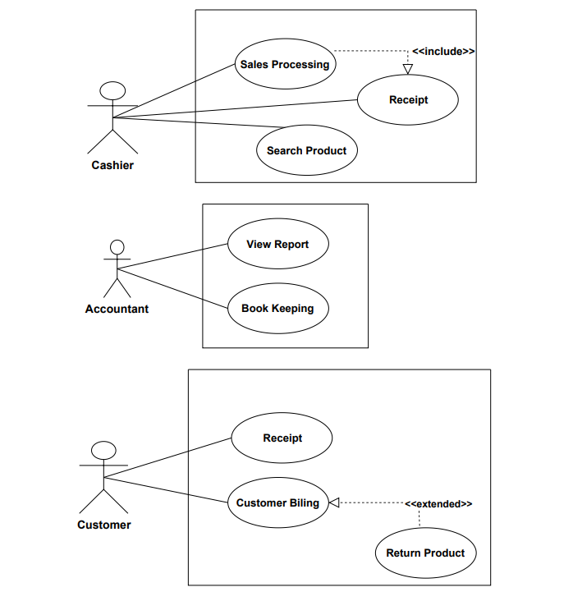
Generate Receipt
Artifact no 2

UC-10 — User Authentication (Login / Logout)
Field | Content
Use Case No. | UC-10
Name | User Authentication (Login / Logout)
Primary Actor | Any system user (Owner, Manager, Cashier, Accountant, Maintenance)
Secondary Actors | MFA/OTP provider (optional)
Short Description | Authenticate users and create role-based sessions.
Precondition | User account exists / provisioned.
Postcondition | User session established or terminated with correct RBAC.
Normal Flow (sequenced) | 1. User opens system and enters credentials.  2. System validates credentials;  3. System creates session and applies role permissions.
Alternative Flows | 1.1: Invalid credentials → deny access, log attempt.  1.2: Forgotten password → secure reset flow.

UC-11 — Assign & Manage Roles (RBAC)
Field | Content
Use Case No. | UC-11
Name | Assign & Manage Roles
Primary Actor | Store Owner (primary) / Store Manager (delegated)
Secondary Actors | Users receiving roles
Short Description | Create roles, assign users, manage permissions (least privilege).
Precondition | Admin authenticated with role-management rights
Postcondition | Roles updated; audit logged; users notified.
Normal Flow (sequenced) | 1. Admin opens user/role management.  2. Admin assigns/edits role(s) for a user.  3. System validates and saves; notifies user.
Alternative Flows | 1.1: High-privilege role → require Owner approval before applying.

UC-03 — Add New Product
Field | Content
Use Case No. | UC-03
Name | Add New Product
Primary Actor | Store Manager / Admin
Secondary Actors | Supplier (optional), Store Owner (approvals)
Short Description | Create a product record with SKU, pricing, tax, stock, supplier.
Precondition | Manager authenticated with create permission
Postcondition | Product persisted in catalog and available for search/sale.
Normal Flow (sequenced) | 1. Manager opens Add Product form.  2. Manager provides SKU, name, price, tax, initial stock, supplier.  3. System validates SKU uniqueness and required fields.  4. Manager saves; system updates catalog.
Alternative Flows | 1.1: Duplicate SKU → prompt to edit or auto-generate SKU.

UC-04 — Edit / Delete Product
Field | Content
Use Case No. | UC-04
Name | Edit / Delete Product
Primary Actor | Store Manager / Admin
Secondary Actors | Store Owner (if deletion needs approval)
Short Description | Modify product details or mark product inactive / delete.
Precondition | Manager authenticated with edit/delete rights.
Postcondition | Product updated or soft-deleted; audit log saved.
Normal Flow (sequenced) | 1. Manager locates product.  2. Manager updates fields and saves (or requests delete).  3. System validates and writes change; log entry created.
Alternative Flows | 1.1: Active transactions exist → block hard delete and suggest soft-delete.

UC-05 — Search / Filter Products
Field | Content
Use Case No. | UC-05
Name | Search / Filter Products
Primary Actor | Cashier, Store Manager/Admin, Accountant
Secondary Actors | —
Short Description | Find products by SKU, name, barcode or filters; return price & stock.
Precondition | User authenticated; product index available.
Postcondition | Product(s) listed and selectable.
Normal Flow (sequenced) | 1. User enters query or scans barcode.  2. System returns matches with price & stock.  3. User selects: for sale
Alternative Flows | 1.1: No match → suggest close matches or offer

UC-06 — Manual Stock Adjustment
Field | Content
Use Case No. | UC-06
Name | Manual Stock Adjustment
Primary Actor | Store Manager / Admin
Secondary Actors | Store Owner (informed)
Short Description | Adjust inventory counts with mandatory reason and audit.
Precondition | Manager authenticated with adjustment rights.
Postcondition | Stock updated; adjustment logged (before/after, reason, user).
Normal Flow (sequenced) | 1. Manager selects product.  2. Manager enters delta/new quantity + reason.  3. System validates and updates stock.  4. If new stock ≤ threshold → (Low-stock Alert).
Alternative Flows | 1.1: Missing reason → system rejects until reason provided.

UC-07 — Low-stock Alert
Field | Content
Use Case No. | UC-07
Name | Low-stock Alert
Primary Actor | System (automated) / Store Manager (receiver)
Secondary Actors | Supplier (optional)
Short Description | Notify manager/owner when stock falls to or below reorder threshold.
Precondition | Reorder threshold configured for products.
Postcondition | Alert delivered; suggested reorder quantity shown.
Normal Flow (sequenced) | 1. System detects stock ≤ threshold  2. System sends dashboard/email/SMS alert.  3. Manager reviews and places order manually or triggers auto-reorder.
Alternative Flows | 1.1: Auto-reorder enabled → system creates PO to supplier.

UC-01 — Process Sale
Field | Content
Use Case No. | UC-01
Name | Process Sale
Primary Actor | Cashier / Sales Staff
Secondary Actors | Inventory subsystem, Payment gateway, Printer.
Short Description | Sell items to customer; update inventory and record transaction.
Precondition | Cashier authenticated , products exist and are searchable.
Postcondition | Transaction recorded; inventory decremented; sale available in reports.
Normal Flow (sequenced) | 1. Cashier searches/scans product.  2. System shows details; cashier confirms quantities.  3. System validates stock.  4. Cashier selects payment method and pays.  5. System finalizes transaction and decrements stock.  6. System triggers Print Receipt.  7. If stock ≤ threshold, created.  8. Transaction appears in reports.
Alternative Flows | 1.1: Insufficient stock → adjust qty or backorder.  1.2: Payment failure → retry/alternate.  1.3: DB error → queue for retry .

UC-02 — Print Receipt
Field | Content
Use Case No. | UC-02
Name | Print Receipt
Primary Actor | System (invoked)
Secondary Actors | Cashier, Printer
Short Description | Generate and print or deliver digital receipt for sale.
Precondition | Sale transaction completed and stored.
Postcondition | Receipt printed and digital copy stored.
Normal Flow (sequenced) | 1. System formats receipt with transaction details.  2. System sends print job.  3. Receipt printed; digital copy stored.
Alternative Flows | 1.1: Printer offline → provide digital receipt / queue reprint.

UC-12 — Return Products
Field | Content
Use Case No. | UC-12
Name | Return Products
Primary Actor | Customer (initiator) / Cashier (processor)
Secondary Actors | Store Manager (approver for exceptions), Inventory subsystem
Short Description | Process returns, issue refund/store credit and update inventory.
Precondition | Original transaction exists and within return policy
Postcondition | Refund/credit issued; inventory & reports updated.
Normal Flow (sequenced) | 1. Cashier locates original transaction  2. Cashier selects items to return and verifies eligibility.  3. System computes refund and updates inventory.  4. System logs return and updates.
Alternative Flows | 1.1: Outside policy/damaged → escalate to Manager (approval path).

UC-08 — View Reports
Field | Content
Use Case No. | UC-08
Name | View Reports
Primary Actor | Store Owner (primary), Accountant, Store Manager
Short Description | Generate sales/inventory/returns reports for selected periods.
Precondition | User with report permission authenticated; data present.
Postcondition | Report displayed/exported (PDF/CSV) or scheduled.
Normal Flow (sequenced) | 1. User selects report type and date range.  2. System queries and renders report.  3. User downloads or schedules recurring report.
Alternative Flows | 1.1: Heavy query → offer async generation and notify on completion.

ARTIFACT NO 3( ACTIVITY DIAGRAM)
ACTIVITY 1
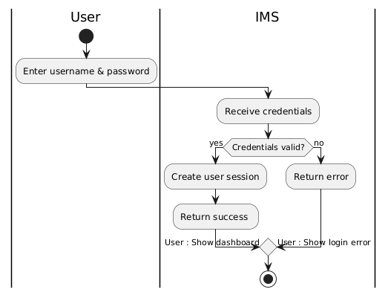

ACTIVITY 2
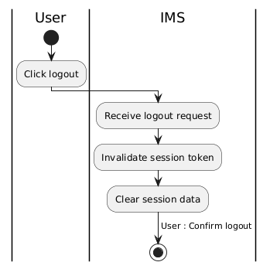

ACTIVITY 3
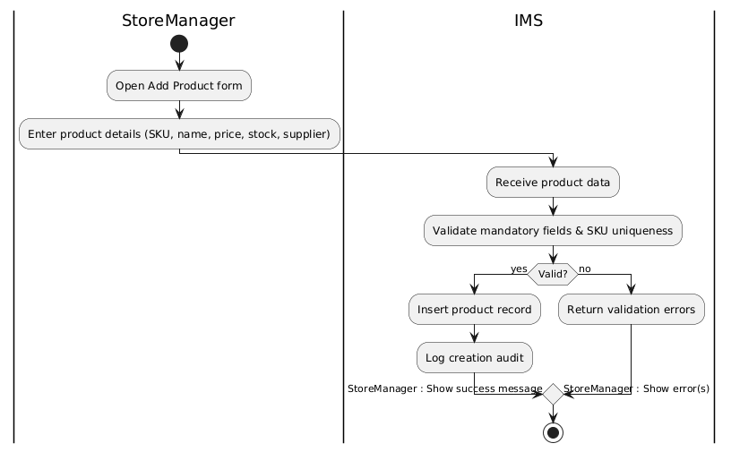
ACTIVITY 4

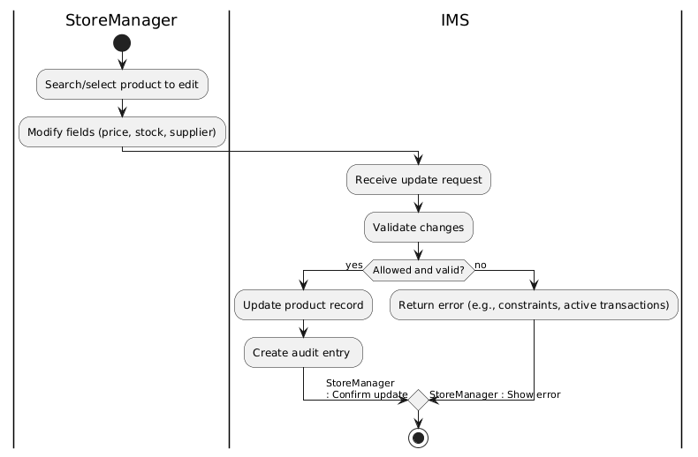

ACTIVITY 5
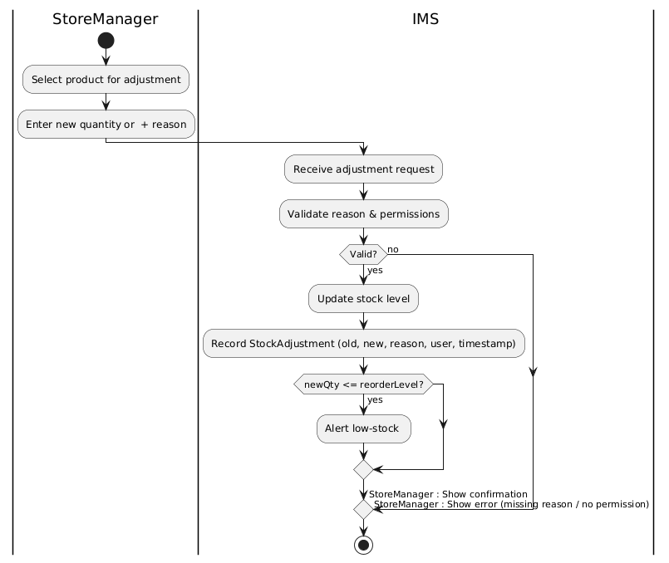

ACTIVITY 6
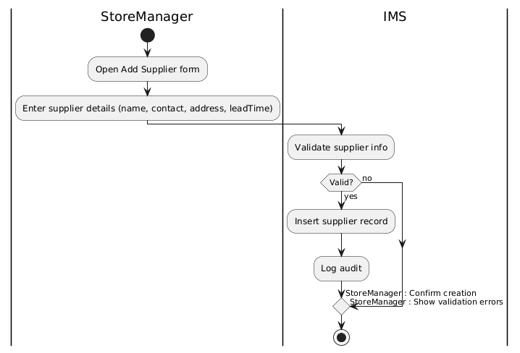

ACTIVITY 7

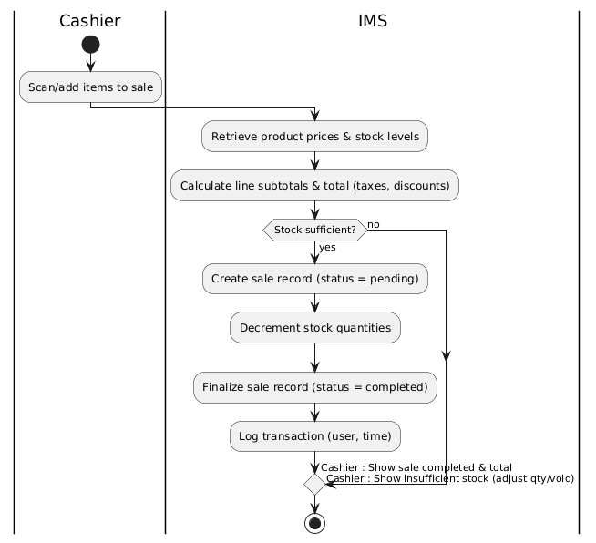

ACTIVITY 8

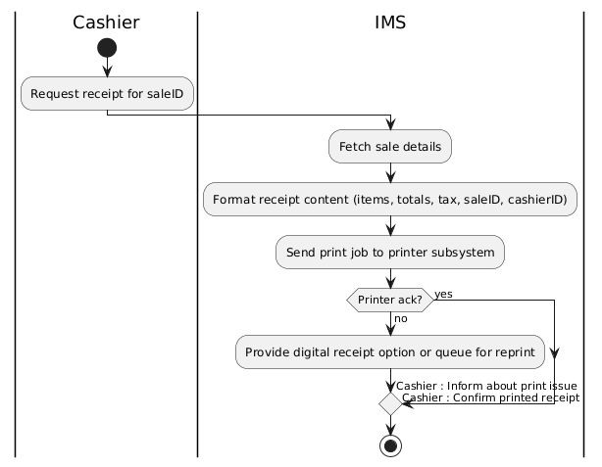
ACTIVITY 9
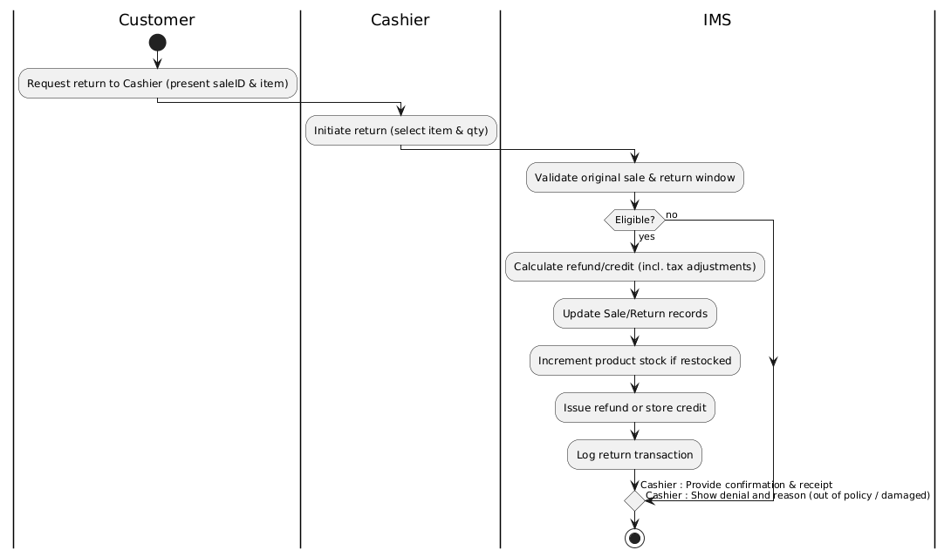

ACTIVITY 10
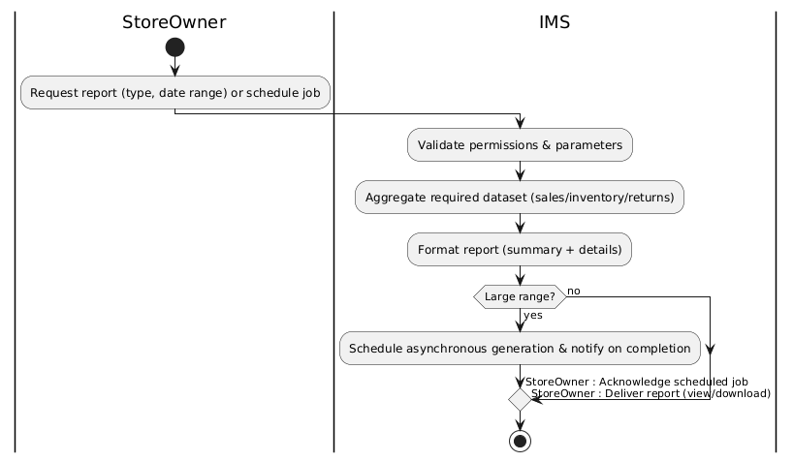

ACTIVITY 11
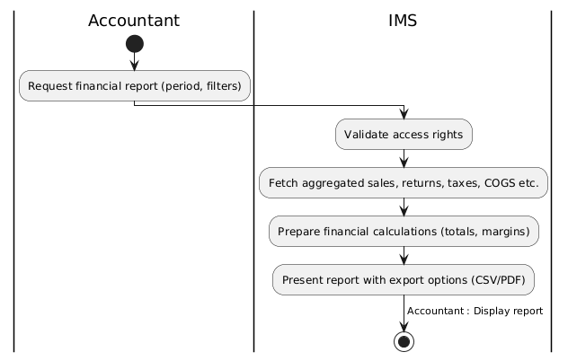
ACTIVITY 12

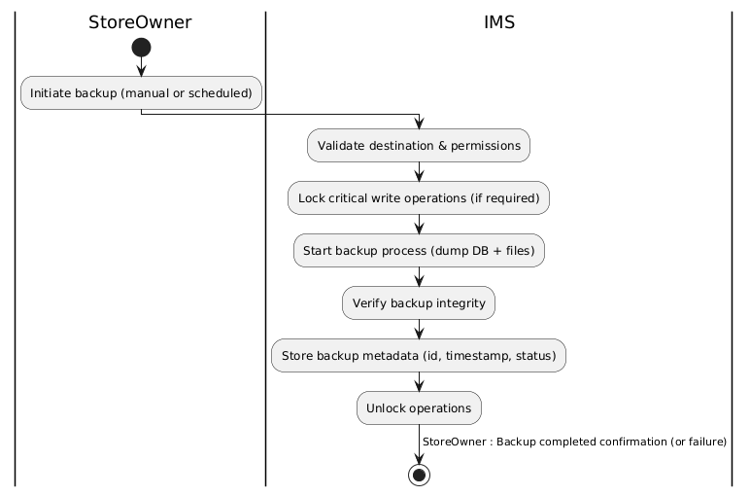

ARTIFACT NO 4
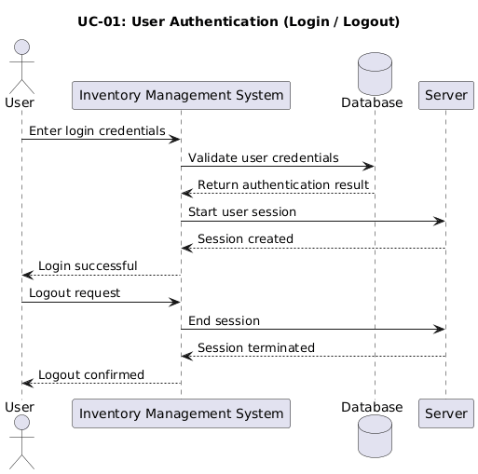
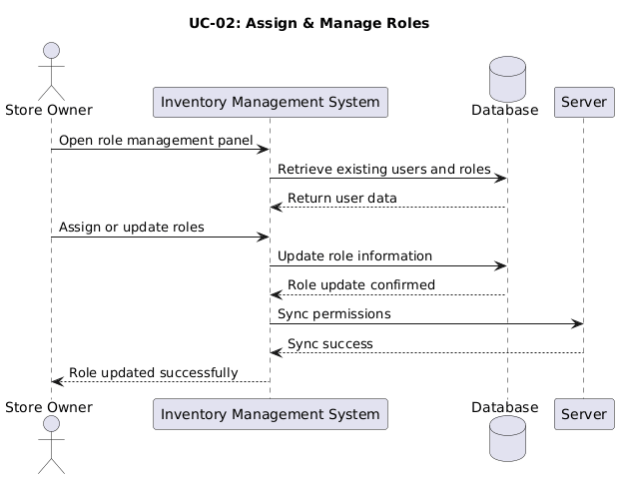
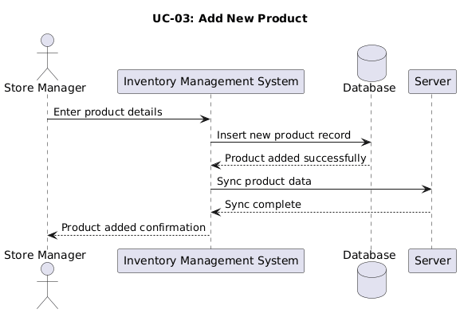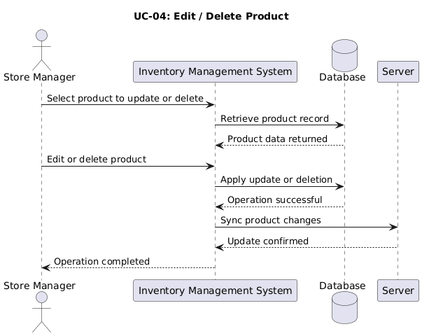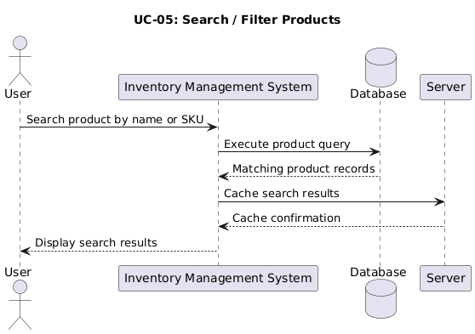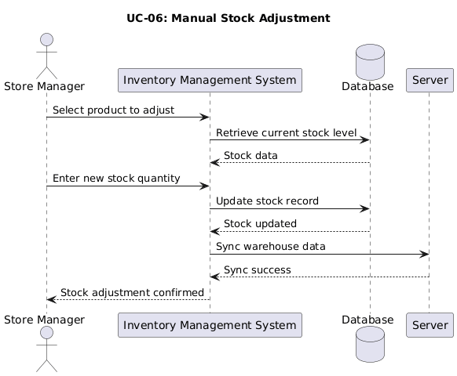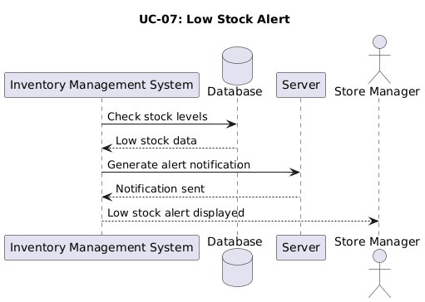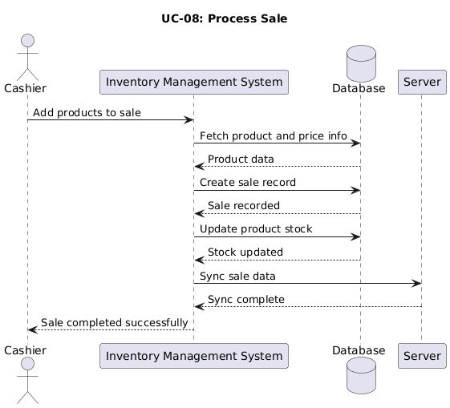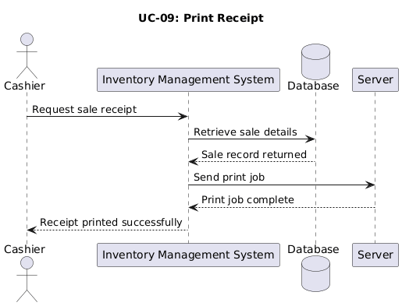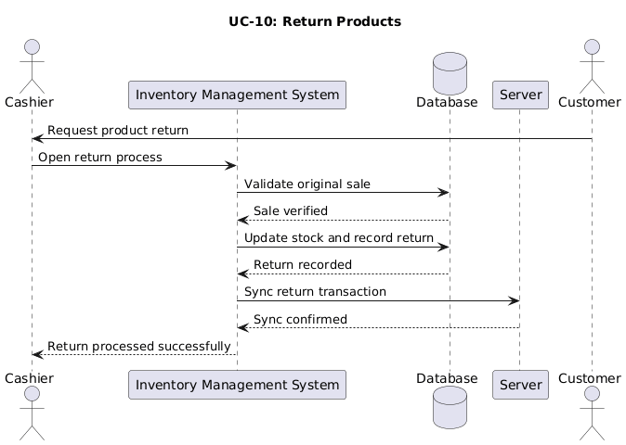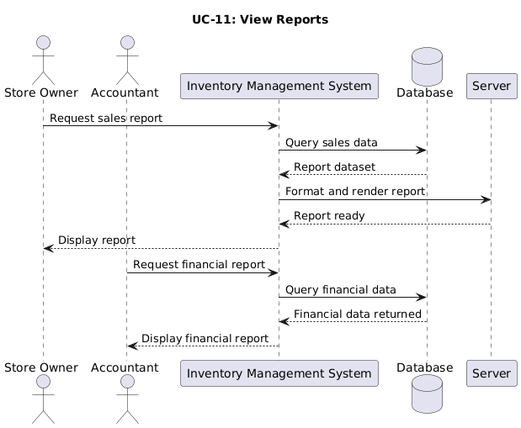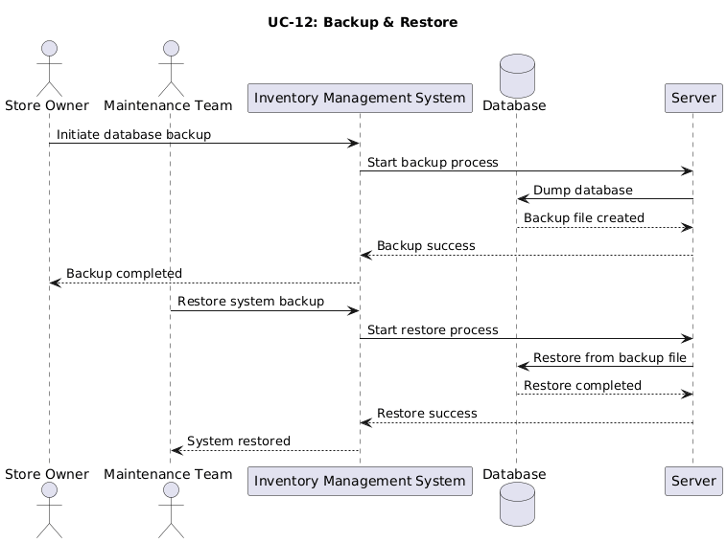
ARTIFACT NO 5

ARTIFACT NO 7
State chart Diagram # 01
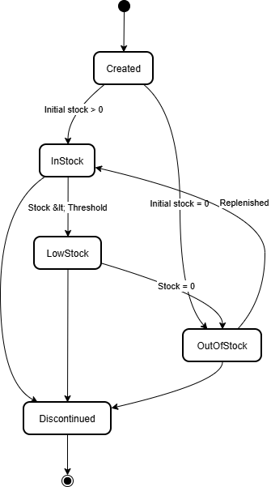

State Chart Diagram No 2
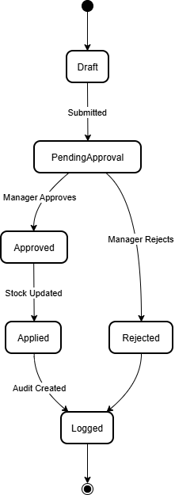

State Chart Diagram No # 03
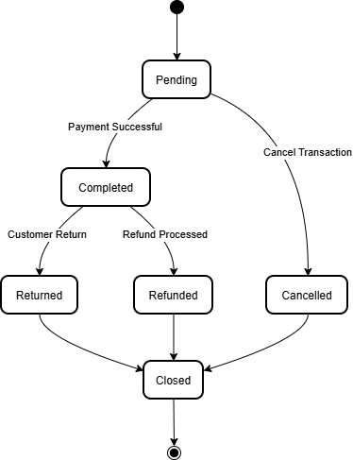

State Chart Diagram No # 04
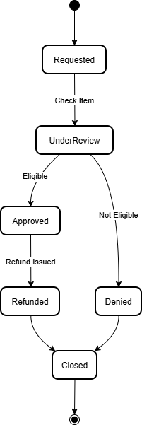

State Chart Diagram No # 05

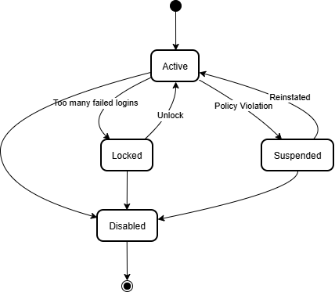

State Chart Diagram No # 06
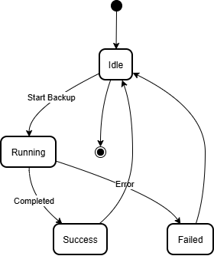

State Chart Diagram No # 07
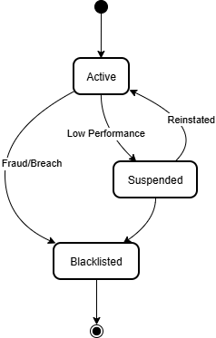
State Chart Diagram No # 08
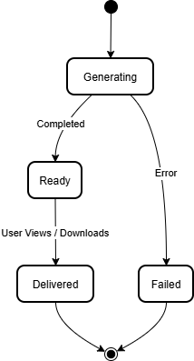

ARTIFACT NO 8
CODE :
import java.util.*;
// ============================================
// MAIN CLASS - SYSTEM DEMO
// ============================================
public class Inventory_Management_system {
public static void main(String[] args) {
System.out.println("=== Inventory Management System ===\n");
// ---------------------------------------------------------
// 1. INDEPENDENT OBJECTS (For Aggregation & Association)
// ---------------------------------------------------------
// created independently in main
Product p1 = new Product(101, "Laptop", "SKU001", 1200.00, 10);
Product p2 = new Product(102, "Mouse", "SKU002", 25.00, 50);
Supplier supplier = new Supplier(501, "TechDistributors");
PaymentGateway gateway = new PaymentGateway(901, "Stripe");
// ---------------------------------------------------------
// 2. USERS
// ---------------------------------------------------------
StoreOwner owner = new StoreOwner(1, "Alice", "pass1", "Alice Owner", "Owner");
StoreManager manager = new StoreManager(2, "Bob", "pass2", "Bob Manager", "Manager");
Cashier cashier = new Cashier(3, "Charlie", "pass3", "Charlie Cashier", "Cashier");
Accountant accountant = new Accountant(4, "Dave", "pass4", "Dave Accountant", "Accountant");
// ---------------------------------------------------------
// 3. STORE MANAGER WORKFLOW (Aggregation)
// ---------------------------------------------------------
System.out.println("--- Store Manager (Aggregation) ---");
// Manager aggregates Products (created in main)
manager.addProduct(p1);
manager.addProduct(p2);
// Manager manages stock (Association return type)
StockAdjustment adj = manager.manageStock(p1, 5);
if(adj != null) adj.record();
// Supplier aggregates Products (created in main)
supplier.addProduct(p1);
manager.createSupplier(supplier);
// ---------------------------------------------------------
// 4. CASHIER & SALES WORKFLOW (Composition)
// ---------------------------------------------------------
System.out.println("\n--- Cashier & Sales (Composition) ---");
List<Product> itemsToBuy = new ArrayList<>();
itemsToBuy.add(p1);
itemsToBuy.add(p2);
// Cashier creates the Sale object
Sale sale = cashier.processSale(itemsToBuy);
// COMPOSITION: OrderItems are created INSIDE sale.addOrderItem()
// (See the Sale class definition below)
sale.calculateTotal();
// COMPOSITION: Receipt is created INSIDE sale.generateReceipt()
Receipt receipt = cashier.printReceipt(sale);
if(receipt != null) receipt.print();

// COMPOSITION: Payment is created INSIDE the Sale class logic
// We simulate the payment trigger here via the Sale object
// The Gateway is passed (Association)
sale.triggerPayment(gateway, "Credit Card");
// ---------------------------------------------------------
// 5. RETURN WORKFLOW (Association)
// ---------------------------------------------------------
System.out.println("\n--- Return Process (Association) ---");
// Return object created in main
Return returnItem = new Return(1, sale.saleID, p2.productID, 1);
// Passed as parameter to cashier
cashier.processReturn(returnItem);

// ---------------------------------------------------------
// 6. STORE OWNER WORKFLOW (Composition)
// ---------------------------------------------------------
System.out.println("\n--- Store Owner (Composition) ---");
// Report is created, which internally creates Analytics
Report report = owner.generateReport("Sales", "Monthly");
report.generate(); // Uses internal Analytics
report.export("PDF");

Backup backup = owner.initiateBackup();
backup.perform();

// ---------------------------------------------------------
// 7. NOTIFICATION (Association)
// ---------------------------------------------------------
System.out.println("\n--- Notification ---");
Notification notif = new Notification(88, "System update scheduled");
notif.send();

System.out.println("\n=== SYSTEM END ===");
}
}

// ============================================
// ABSTRACT USER CLASS
// ============================================
abstract class User {
private int userID;
private String username;
private String password;
private String name;
private String role;

public User(int userID, String username, String password, String name, String role) {
this.userID = userID;
this.username = username;
this.password = password;
this.name = name;
this.role = role;
}

public boolean login() {
System.out.println(role + " " + name + " logged in.");
return true;
}
public void logout() {}
public void updateProfile() {}
}

// ============================================
// USER SUBCLASSES
// ============================================
class StoreOwner extends User {
private int ownerID;

public StoreOwner(int userID, String username, String password, String name, String role) {
super(userID, username, password, name, role);
this.ownerID = userID;
}

public Report generateReport(String type, String range) {
System.out.println("StoreOwner generating report...");
return new Report(1, type);
}

public boolean manageRoles(User user, String newRole) {
System.out.println("StoreOwner updated role.");
return true;
}

public Backup initiateBackup() {
System.out.println("StoreOwner initiated backup.");
return new Backup(100, "/data/backup.db");
}
}

class StoreManager extends User {
private int managerID;
// Aggregation: List of products created externally
private List<Product> managedProducts;

public StoreManager(int userID, String username, String password, String name, String role) {
super(userID, username, password, name, role);
this.managerID = userID;
this.managedProducts = new ArrayList<>();
}

public boolean addProduct(Product product) {
// Aggregation: Adding external object
managedProducts.add(product);
System.out.println("Manager added product: " + product.name);
return true;
}

public boolean editProduct(int productID, double newPrice) {
System.out.println("Manager edited product " + productID);
return true;
}

public StockAdjustment manageStock(Product product, int qtyDelta) {
System.out.println("Manager adjusting stock for " + product.name);
return new StockAdjustment(1, product.productID, product.stockQty, product.stockQty + qtyDelta, "Restock");
}

public boolean createSupplier(Supplier supplier) {
System.out.println("Manager created supplier: " + supplier.name);
return true;
}
}

class Cashier extends User {
private int cashierID;

public Cashier(int userID, String username, String password, String name, String role) {
super(userID, username, password, name, role);
this.cashierID = userID;
}

public Sale processSale(List<Product> products) {
System.out.println("Cashier processing new sale...");
Sale sale = new Sale(500, cashierID);
// Logic to add products to sale
for (Product p : products) {
sale.addOrderItem(p, 1);
}
return sale;
}

public Receipt printReceipt(Sale sale) {
System.out.println("Cashier printing receipt.");
return sale.generateReceipt();
}

public boolean processReturn(Return returnItem) {
// Association: Return object passed as parameter
System.out.println("Cashier processing return for Item: " + returnItem.productID);
return returnItem.processReturn();
}
}

class Accountant extends User {
private int accountantID;

public Accountant(int userID, String username, String password, String name, String role) {
super(userID, username, password, name, role);
this.accountantID = userID;
}

public Report viewFinancialReport(String range) {
System.out.println("Accountant viewing financial report.");
return new Report(2, "Financial");
}
}

// ============================================
// ENTITIES (Product, Supplier)
// ============================================
class Product {
public int productID;
public String name;
public String SKU;
public double price;
public int stockQty;

public Product(int productID, String name, String SKU, double price, int stockQty) {
this.productID = productID;
this.name = name;
this.SKU = SKU;
this.price = price;
this.stockQty = stockQty;
}

public void updatePrice(double newPrice) { this.price = newPrice; }
public boolean checkAvailability(int qty) { return stockQty >= qty; }
}

class Supplier {
private int supplierID;
public String name;
// Aggregation: List of products
private List<Product> suppliedProducts;

public Supplier(int supplierID, String name) {
this.supplierID = supplierID;
this.name = name;
this.suppliedProducts = new ArrayList<>();
}

public void addProduct(Product product) {
suppliedProducts.add(product);
}
}

// ============================================
// SYSTEM OBJECTS
// ============================================
class StockAdjustment {
private int adjustmentID;
private int productID;
private int oldQty;
private int newQty;
private String reason;

public StockAdjustment(int adjustmentID, int productID, int oldQty, int newQty, String reason) {
this.adjustmentID = adjustmentID;
this.productID = productID;
this.oldQty = oldQty;
this.newQty = newQty;
this.reason = reason;
}

public void record() {
System.out.println("Stock Adjustment recorded.");
}
}

// ============================================
// SALE & COMPOSITION CLASSES
// ============================================
class Sale {
public int saleID;
private int cashierID;
private double totalAmount;
// Composition: Parts created inside Sale
private List<OrderItem> orderItems;
private Receipt receipt;
private Payment payment;

public Sale(int saleID, int cashierID) {
this.saleID = saleID;
this.cashierID = cashierID;
// Composition: List initialized internally
this.orderItems = new ArrayList<>();
}

public void addOrderItem(Product product, int qty) {
// COMPOSITION: OrderItem created INSIDE Sale
// It cannot exist without this Sale
OrderItem item = new OrderItem(orderItems.size() + 1, product.productID, qty, product.price);
orderItems.add(item);
}

public double calculateTotal() {
totalAmount = 0;
for (OrderItem item : orderItems) {
totalAmount += item.subtotal();
}
System.out.println("Sale Total Calculated: " + totalAmount);
return totalAmount;
}

public Receipt generateReceipt() {
// COMPOSITION: Receipt created INSIDE Sale
this.receipt = new Receipt(700, saleID);
return this.receipt;
}

// Helper method to trigger the Payment Composition logic
public void triggerPayment(PaymentGateway gateway, String method) {
// COMPOSITION: Payment created INSIDE Sale
this.payment = new Payment(800, this.saleID, this.totalAmount, method);
this.payment.processPayment(gateway);
}
}

class OrderItem {
private int orderItemID;
private int productID;
private int quantity;
private double unitPrice;

public OrderItem(int orderItemID, int productID, int quantity, double unitPrice) {
this.orderItemID = orderItemID;
this.productID = productID;
this.quantity = quantity;
this.unitPrice = unitPrice;
}

public double subtotal() {
return quantity * unitPrice;
}
}

class Receipt {
private int receiptID;
private int saleID;

public Receipt(int receiptID, int saleID) {
this.receiptID = receiptID;
this.saleID = saleID;
}

public void print() {
System.out.println("Printing Receipt #" + receiptID + " for Sale #" + saleID);
}
}

class Payment {
private int paymentID;
private int saleID;
private double amount;
private String method;

public Payment(int paymentID, int saleID, double amount, String method) {
this.paymentID = paymentID;
this.saleID = saleID;
this.amount = amount;
this.method = method;
}

// Association: Gateway passed as parameter
public boolean processPayment(PaymentGateway gateway) {
System.out.println("Processing internal payment...");
return gateway.initiatePayment(this);
}
}

class PaymentGateway {
private int gatewayID;
private String providerName;

public PaymentGateway(int gatewayID, String providerName) {
this.gatewayID = gatewayID;
this.providerName = providerName;
}

public boolean initiatePayment(Payment payment) {
System.out.println("Gateway " + providerName + " processing payment.");
return true;
}
}

class Return {
private int returnID;
private int saleID;
public int productID;
private int quantity;

public Return(int returnID, int saleID, int productID, int quantity) {
this.returnID = returnID;
this.saleID = saleID;
this.productID = productID;
this.quantity = quantity;
}

public boolean processReturn() {
System.out.println("Return processed successfully.");
return true;
}
}

// ============================================
// REPORTING & UTILITIES
// ============================================
class Report {
private int reportID;
private String type;
// Composition: Report owns Analytics
private Analytics analytics;

public Report(int reportID, String type) {
this.reportID = reportID;
this.type = type;
// COMPOSITION: Created inside
this.analytics = new Analytics();
}

public void generate() {
System.out.println("Generating Report: " + type);
analytics.summarize();
analytics.trendAnalysis();
}

public String export(String format) {
System.out.println("Report exported as " + format);
return "file." + format;
}
}

class Analytics {
public void summarize() {
System.out.println("Analytics: Summarizing Data...");
}

public void trendAnalysis() {
System.out.println("Analytics: Analyzing Trends...");
}
}

class Notification {
private int notificationID;
private String message;

public Notification(int notificationID, String message) {
this.notificationID = notificationID;
this.message = message;
}

public void send() {
System.out.println("Notification Sent: " + message);
}
}

class Backup {
private int backupID;
private String filePath;

public Backup(int backupID, String filePath) {
this.backupID = backupID;
this.filePath = filePath;
}

public boolean perform() {
System.out.println("Backup performed to " + filePath);
return true;
}
}

